Bethany Lutheran Church- Council Minutes October 14th, 2024

Call to Order at 6:30 by President Kent Kaufman

Members Present: Jon Twing, Dale Swenson, Pastor Chad, Cindy Knoop, Kent Kaufman, Kristen Van Scoyoc, Howard Moss, Courtney Heid

Members absent: Pat Cassabaum, Jessica Fonseca

Opening Prayer & Discussion

Pastor’s Report
Joys and Thanksgivings
- Faith Forward events (Open House and High School Night)
- Choir singing/staff appreciation Sunday
- Community Tailgate

Ministry Happenings
- Faith Forward Events
  - 7 youth @ high school event
  - 51 people @ open house
  - More kits taken after church yesterday
- Faith Forward mentor and cohort meetings
- Sermon Camp (Continuing Education)
  - Concluded in September after 6 weeks
- Community Tailgate
  - Well attended by students and families
- Fall Conference (Southeastern Iowa Synod)
  - Topic – Christian Nationalism
- Crestview Worship
  - 4 in attendance
  - Recently asked if I would lead worship at a new facility in Iowa City I was recently visiting a parishioner at
- Funeral of Richard Madsen
- Worship Meeting
  - Thanks to Cindy for leading and those present: Beth, Linda, Jill B.
- West Branch Area Religious Council Meeting (WBARC)
  - No recent expenditures
  - Wal-Mart gift cards will be provided to resource counselor to provide to families in need
  - Updated resource brochure being worked on
- Attend quilters group often
- Wednesday men’s Bible study group
- Pastoral Visits: 15

Upcoming
- Vacation – 10/19-10/22

*These pie charts are a way of monitoring my activities and provides a graphic. The first is a detailed pie chart showing specific duties. The second is an attempt to combine these into more general ministry terminology that reflects our budget. Remember, this is a snapshot of one month and each month changes. This month will most likely see a large uptick in pastoral care and a decline in continuing education.

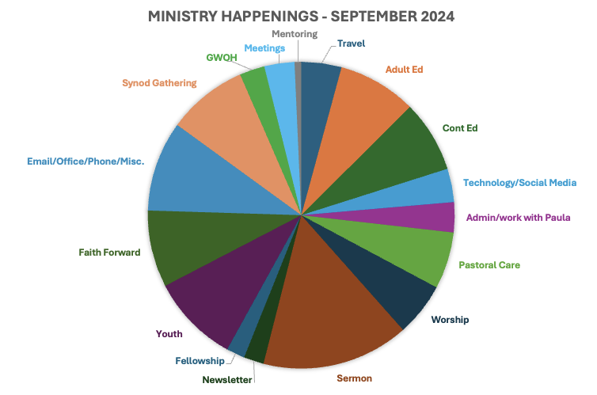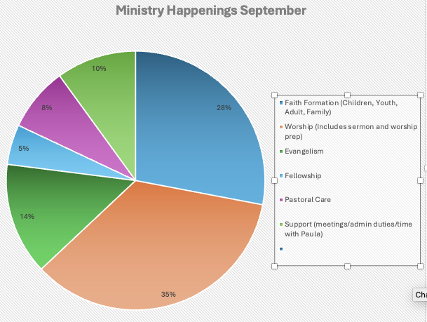

Secretary’s Report - Courtney

- September Council Meeting Minutes
  - Howard moved to approve; Kristen seconded. Motion approved.

Treasurer’s Report - Jon

- August Treasurer’s Report (was tabled in September due to books not being closed)
  - Kristen moved to approve; Howard seconded. Motion approved.
- September Treasurer’s Report
  - Howard moved to approve; Kristen seconded. Motion approved.

Committee Reports

Building and Grounds – Howard

- The city water main project affecting the church and parsonage is complete.

Education & Youth - Kristen & Courtney

- Christmas program prep
  - Planned for Sunday, December 15th

Evangelism & Missions – Jessica via email

- Saturday October 19th I will be delivering the personal care kits that were made during God's Work Our Hands. I will be dropping them off at the Trinity Lutheran Church in Cedar Rapids. We ended up with a total of 63 kits.

Fellowship – Pat via email
- The 4th Sunday Meals:
  - October - Del & Sue Hughes
  - November - Paul & Nancy Bruns
  - December – no meal

Stewardship - Dale
- Temple talks have been going well, two more planned
- Looking at getting reusable water bottles and bags as well as potentially getting a bottle filling station in the church. Use memorial funds?
- October 3rd – stewardship providing fellowship

Worship and Music – Cindy
- October 20th – Hymn sing Sunday
- October 27th – Reformation Sunday
- November 3rd – All Saints Sunday
- Christmas season planning
- Looking at Christ/Pascal candle replacement

Old Business
- Capital Improvement Fund
  - Multiple items on list for church building and parsonage – we need to prioritize
    - Kent motioned to replace storm door for parsonage using Capital Improvement Fund; Kristen seconded. Motion approved.
- Solar Tax Credit – Jon working on getting information needed to fill out forms. Many hurdles with government changes.

New Business
- Church use request:
  - Alda is the Cedar County Rep for DVIP – asking to use some church space as a remote workplace occasionally. Chad gathering more information about details of this.
- Reminder to start thinking about 2025 budget requests for committee
- Nominating Committee (responsible for finding replacements for outgoing council members)
  - Dave Poppen
  - Jill Taylor
  - Sue Hughes

Howard moved to adjourn the meeting at 08:01pm, Kristen seconded. Motion approved.

Closed with the Lord’s Prayer

Next Regular Meeting November 11th, 2024

