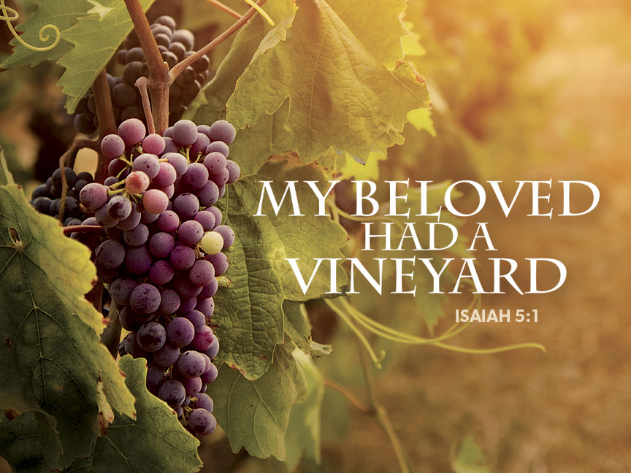

October 8th, 2023
19th Sunday after Pentecost
Bethany Lutheran Church (ELCA)

PRELUDE AND LIGHTING OF CANDLES
RINGING OF BELL
WELCOME
The people of God stand.
CONFESSION AND FORGIVENESS
Blessed be the holy Trinity, ☩ one God,
who forgives all our sin,
whose mercy endures forever.
Amen.
Almighty God, to whom all hearts are open, all desires known, and from whom no secrets are hid: cleanse the thoughts of our hearts by the inspiration of your Holy Spirit, that we may perfectly love you and worthily magnify your holy name, through Jesus Christ our Lord.
Amen.
Let us confess our sin in the presence of God and of one another.
Silence is kept for reflection.
Gracious God,
have mercy on us. We confess that we have turned from you and given ourselves into the power of sin. We are truly sorry and humbly repent. In your compassion forgive us our sins, known and unknown, things we have done and things we have failed to do. Turn us again to you, and uphold us by your Spirit, so that we may live and serve you in newness of life through Jesus Christ, our Savior and Lord.
Amen.
God, who is rich in mercy, loved us even when we were dead in sin, and made us alive together with Christ. By grace you have been saved. In the name of ☩ Jesus Christ, your sins are forgiven. Almighty God strengthen you with power through the Holy Spirit, that Christ may live in your hearts through faith.
Amen.
HYMM When I Survey the Wondrous Cross (ELW 803) See next page.

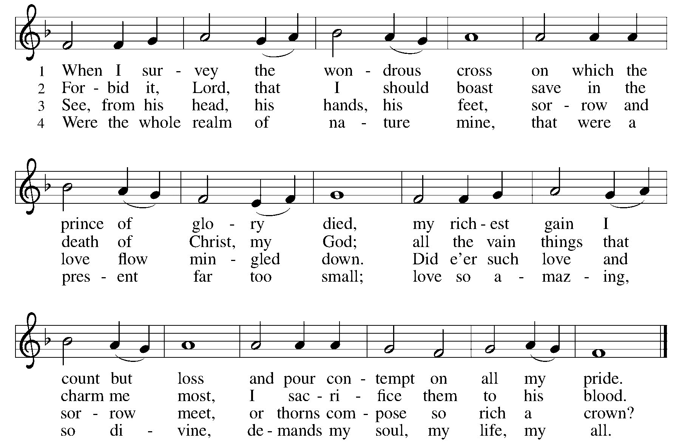

GREETING (ELW p.184)
The grace of our Lord Jesus Christ, the love of God,
and the communion of the Holy Spirit be with you all.
And also with you.

PRAYER OF THE DAY
Let us pray.
Beloved God, from you come all things that are good. Lead us by the inspiration of your Spirit to know those things that are right, and by your merciful guidance, help us to do them, through Jesus Christ, our Savior and Lord.
Amen.
The people of God are seated.
CHOIR ANTHEM “We Can Share His Love”
Word
God speaks to us in scripture reading, preaching, and song.

first READING: Isaiah 5:1-7
The prophet sings a sad, parable-like love song about the relationship between God and Israel. In this song Israel is compared to a promising vineyard. Despite God’s loving care, the vineyard that is Israel has brought forth “wild grapes” of injustice and distress, when fine grapes of justice and righteousness were expected.
A reading from Isaiah.
¹Let me sing for my beloved my love-song concerning his vineyard: My beloved had a vineyard
on a very fertile hill. ²He dug it and cleared it of stones, and planted it with choice vines; he built a watchtower in the midst of it, and hewed out a wine vat in it; he expected it to yield grapes, but it yielded wild grapes.
³And now, inhabitants of Jerusalem and people of Judah, judge between me and my vineyard. ⁴What more was there to do for my vineyard that I have not done in it? When I expected it to yield grapes, why did it yield wild grapes?
⁵And now I will tell you what I will do to my vineyard. I will remove its hedge, and it shall be devoured; I will break down its wall, and it shall be trampled down. ⁶I will make it a waste; it shall not be pruned or hoed, and it shall be overgrown with briers and thorns; I will also command the clouds that they rain no rain upon it.
⁷For the vineyard of the Lord of hosts is the house of Israel, and the people of Judah
are his pleasant planting he expected justice, but saw bloodshed; righteousness, but heard a cry!
The word of the Lord. Thanks be to God.
PSALM 80:7-15
⁷Restore us, O God of hosts;
let your face shine upon us, and we shall be saved.
⁸You have brought a vine out of Egypt;
you cast out the nations and planted it.
⁹You cleared the ground for it;
it took root and filled the land.
¹⁰The mountains were covered by its shadow
and the towering cedar trees by its boughs.
¹¹You stretched out its tendrils to the sea
and its branches to the river.
¹²Why have you broken down its wall,
so that all who pass by pluck off its grapes?
¹³The wild boar of the forest has ravaged it,
and the beasts of the field have grazed upon it.
¹⁴Turn now, O God of hosts,
look down from heaven;
¹⁵behold and tend this vine;
preserve what your right hand has planted.

SECOND READING: Philippians 3:4b-14
Paul reviews some of his supposed credentials, which no longer have any bearing in comparison to the right relationship he has been given through the death of Christ. The power of Christ’s resurrection motivates him to press on toward the ultimate goal, eternal life with Christ.
A reading from Philippians.
[Paul writes:] ^{4b}If anyone else has reason to be confident in the flesh, I have more: ⁵circumcised on the eighth day, a member of the people of Israel, of the tribe of Benjamin, a Hebrew born of Hebrews; as to the law, a Pharisee; ⁶as to zeal, a persecutor of the church; as to righteousness under the law, blameless.
⁷Yet whatever gains I had, these I have come to regard as loss because of Christ. ⁸More than that, I regard everything as loss because of the surpassing value of knowing Christ Jesus my Lord. For his sake I have suffered the loss of all things, and I regard them as rubbish, in order that I may gain Christ ⁹and be found in him, not having a righteousness of my own that comes from the law, but one that comes through faith in Christ, the righteousness from God based on faith. ¹⁰I want to know Christ and the power of his resurrection and the sharing of his sufferings by becoming like him in his death, ¹¹if somehow I may attain the resurrection from the dead.
¹²Not that I have already obtained this or have already reached the goal; but I press on to make it my own, because Christ Jesus has made me his own. ¹³Beloved, I do not consider that I have made it my own; but this one thing I do: forgetting what lies behind and straining forward to what lies ahead, ¹⁴I press on toward the goal for the prize of the heavenly call of God in Christ Jesus.
The word of the Lord.
Thanks be to God.
The people of God stand.
GOSPEL ACCLAMATION Halle, Halle, Hallelujah (ELW 172)
GOSPEL READING Matthew 21:33-46
Jesus tells a parable to the religious leaders who are plotting his death, revealing that their plans will, ironically, bring about the fulfillment of scripture.
The holy gospel according to Matthew.
Glory to you, O Lord.

[Jesus said to the people:] ³³“Listen to another parable. There was a landowner who planted a vineyard, put a fence around it, dug a wine press in it, and built a watchtower. Then he leased it to tenants and went to another country. ³⁴When the harvest time had come, he sent his slaves to the tenants to collect his produce. ³⁵But the tenants seized his slaves and beat one, killed another, and stoned another. ³⁶Again he sent other slaves, more than the first; and they treated them in the same way. ³⁷Finally he sent his son to them, saying, ‘They will respect my son.’ ³⁸But when the tenants saw the son, they said to themselves, ‘This is the heir; come, let us kill him and get his inheritance.’ ³⁹So they seized him, threw him out of the vineyard, and killed him. ⁴⁰Now when the owner of the vineyard comes, what will he do to those tenants?” ⁴¹They said to him, “He will put those wretches to a miserable death, and lease the vineyard to other tenants who will give him the produce at the harvest time.”
⁴²Jesus said to them, “Have you never read in the scriptures: ‘The stone that the builders rejected has become the cornerstone; this was the Lord’s doing, and it is amazing in our eyes’? ⁴³Therefore I tell you, the kingdom of God will be taken away from you and given to a people that produces the fruits of the kingdom. ⁴⁴The one who falls on this stone will be broken to pieces; and it will crush anyone on whom it falls.”
⁴⁵When the chief priests and the Pharisees heard his parables, they realized that he was speaking about them. ⁴⁶They wanted to arrest him, but they feared the crowds, because they regarded him as a prophet.
The gospel of the Lord.
Praise to you, O Christ.
The people of God are seated.
SERMON
The people of God stand.
Hymn My Lord of Light (ELW 832) See next page.

The people of God are seated.
THANKSGIVING FOR STAFF
A reading from 1 Corinthians 15:57-58 (NIV):
Thanks be to God! He gives us the victory through our Lord Jesus Christ. Therefore, my dear brothers and sisters stand firm. Let nothing move you. Always give yourselves fully to the work of the Lord because you know that your labor in the Lord is not in vain.
For your work of faith, labor of love and steadfastness of hope in our Lord Jesus Christ,
We rejoice and give thanks to God for you.
For the variety of gifts the Spirit has equipped each of you with that help us glorify and worship God, be a place of welcome for all people, and proclaim the good news of Jesus Christ,
We rejoice and give thanks to God for you.
For the joy you give and the light of Christ that shines through each of you,
We rejoice and give thanks to God for you.
For the blessing and gift you are to our community of faith,
We rejoice and give thanks to God for all of you.
Let us pray.
Gracious God, as you have called workers to varied tasks in the world and in your church, so have you called these servants to ministries at Bethany. Grant them joy and a spirit of bold trust, that their work may stir up each of us to a life of fruitful service, through your Son, Jesus Christ our Lord.
Amen.

May the Lord bless your work.
May the Lord strengthen you for service.
May the steadfast love of the Lord be with you always.
Amen.
Prayers of Intercession
With the whole people of God in Christ Jesus, let us pray for the church, those in need, and all of God’s creation.
Each petition ends with, "Lord, in your mercy.” Those worshipping respond with the hymn below “Lord, Listen to Your Children Praying” (ELW 752)
Into your hands, gracious God, we commend all for whom we pray, trusting in your mercy, through Jesus Christ, our Savior.
Amen.
Peace
The peace of Christ be with you always.
And also with you.
The people of God are seated.
OFFERING
We are grateful for your gifts and they are needed to continue the work of the church. For those worshipping online, options on ways to give are found on our website (www.wbbethany.org). Thank you! After the offering is gathered, we sing the people of God stand and sign the hymn below as the gifts are brought forward.
OFFERTORY HYMN Lord, Let My Heart Be Good Soil (ELW 512) See next page.
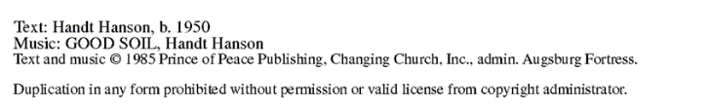
OFFERING PRAYER
Blessed are you, O God, ruler of heaven and earth. Day by day you shower us with blessings. As you have raised us to new life in Christ, give us glad and generous hearts, ready to praise you and to respond to those in need, through Jesus Christ, our Savior and Lord. Amen.
Lord’s Prayer (ELW p.191).

Our Father, who art in heaven,
hallowed be thy name,
thy kingdom come,
thy will be done,
on earth as it is in heaven.
Give us this day our daily bread;
and forgive us our trespasses,
as we forgive those
who trespass against us;
and lead us not into temptation,
but deliver us from evil.
For thine is the kingdom,
and the power, and the glory,
forever and ever. Amen.

SENDING
God blesses us and sends us in mission to the world.

BLESSING
The Lord bless you and keep you.
The Lord’s face shine on you with grace and mercy.
The Lord look upon you with favor and ☩ give you peace. Amen.
BENEDICTION “Go in Love”
SENDING
Go in peace. Share the good news.
Thanks be to God.
POSTLUDE
OUR WORSHIP ASSISTANTS
Ministers of: | Today | October 15
Music | Jill Barnhart | Jill Barnhart
Proclamation (Lector) | Pat Cassabaum | Phil Hougen
Minister of Technology | Dave Poppen | Paula Casper
Worship (Altar Care) | Kent & Beth Kaufman | Kent & Beth Kaufman
Ministers of Hospitality | Patsy Ernst | Paula Casper
This worship service is being streamed live via Facebook and will also be posted to our Website and X (formerly Twitter). The camera captures anyone in the first few pews of our worship space and beyond extending to the altar.

Thank you for worshipping with us today. Just as Jesus welcomed the stranger, we believe all are welcome here. Please join us again next week. For more information about our life together in Christ, visit: www.wbbethany.org

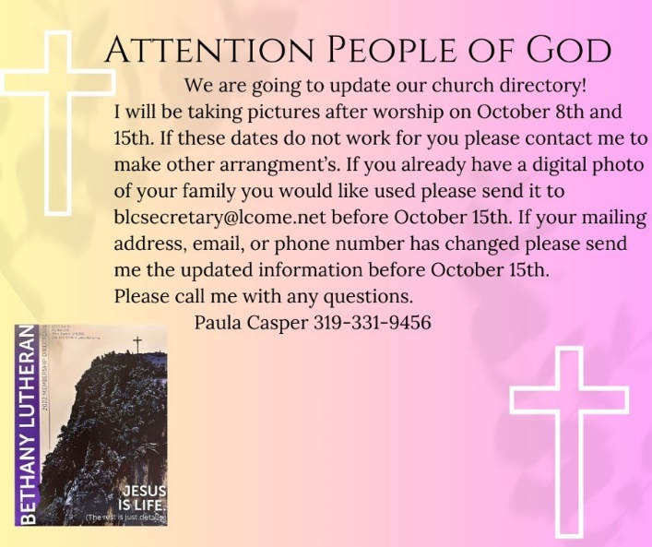
Ministry Opportunities This Week

Wednesday, October 11
7:00 AM - Men’s Bible Study with Breakfast
6:15 PM - Choir practice
6:30 PM – Youth Formation (Grades 3-8)
Thursday, October 12
6:00 AM — Women’s Bible Study
1:00 PM — Quilting Group
Sunday, October 15
9:30 AM — Worship
10:30 AM — Fellowship

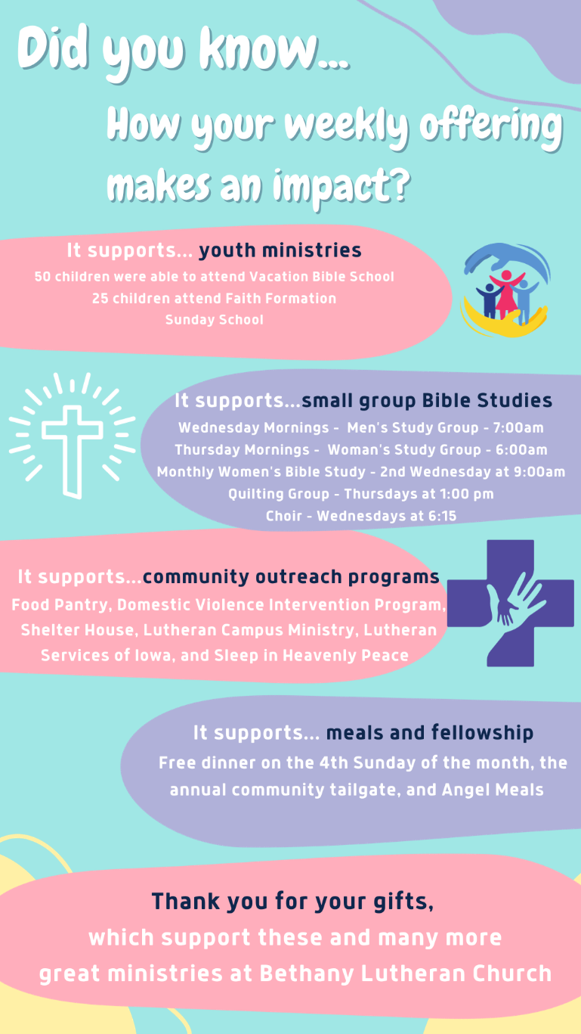

Liturgy from sundaysandseasons.com. Copyright © 2020 Augsburg Fortress. All rights reserved. Used by permission of Augsburg Fortress under license # SB135727.
My Lord of Light (ELW 832); Text © 1980, Jubilate Hymns, admin. Hope Publishing Company. All rights reserved. Used by permission under OneLicense.net A-726405 streaming license.
Lord, Listen to Your Children Praying (ELW 752); Text and Music © 1973 Hope Publishing Company. All rights reserved. Used by permission under OneLicense.net A-726405 streaming license.
Change My Heart, O God (ELW 801); Text and music © 1982 Mercy/Vineyard Publishing (ASCAP), admin. Music Services. Used by permission under OneLicense.net A-726405 streaming license.
Scripture from New Revised Standard Version Bible, Copyright © 1989, Division of Christian Education of the National Council of the Churches of Christ in the United States of America. Used by permission. All rights reserved.

