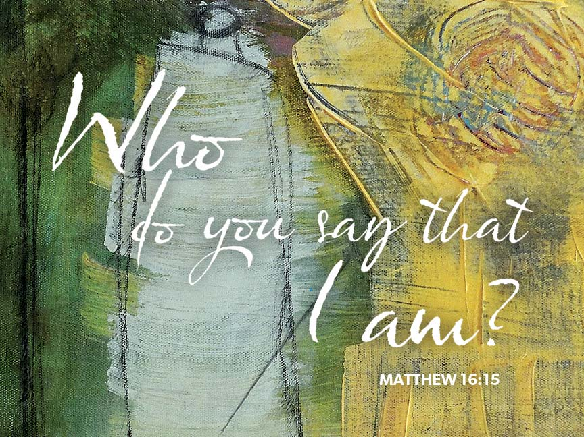

August 27, 2023
13th Sunday after Pentecost
Bethany Lutheran Church (ELCA)

PRELUDE AND LIGHTING OF CANDLES
RINGING OF BELL
WELCOME
The people of God stand.
CONFESSION AND FORGIVENESS
Blessed be the holy Trinity, ☩ one God,
who forgives all our sin,
whose mercy endures forever.
Amen.
Almighty God, to whom all hearts are open, all desires known, and from whom no secrets are hid: cleanse the thoughts of our hearts by the inspiration of your Holy Spirit, that we may perfectly love you and worthily magnify your holy name, through Jesus Christ our Lord.
Amen.
Let us confess our sin in the presence of God and of one another.
Silence is kept for reflection.
Gracious God,
have mercy on us. We confess that we have turned from you and given ourselves into the power of sin. We are truly sorry and humbly repent. In your compassion forgive us our sins, known and unknown, things we have done and things we have failed to do. Turn us again to you, and uphold us by your Spirit, so that we may live and serve you in newness of life through Jesus Christ, our Savior and Lord.
Amen.
God, who is rich in mercy, loved us even when we were dead in sin, and made us alive together with Christ. By grace you have been saved. In the name of ☩ Jesus Christ, your sins are forgiven. Almighty God strengthen you with power through the Holy Spirit, that Christ may live in your hearts through faith.
Amen.
HYMM We All Are One In Mission (ELW 576) See next page.

GREETING (ELW p.184)
The grace of our Lord Jesus Christ, the love of God,
and the communion of the Holy Spirit be with you all.
And also with you.
PRAYER OF THE DAY
Let us pray.
O God, with all your faithful followers of every age, we praise you, the rock of our life. Be our strong foundation and form us into the body of your Son, that we may gladly minister to all the world, through Jesus Christ, our Savior and Lord.
Amen.
The people of God are seated.
Word
God speaks to us in scripture reading, preaching, and song.

first READING: Isaiah 51:1-6
Just as God had called Abraham and Sarah and given them many descendants, so now God offers comfort to Zion. God’s deliverance will come soon and will never end.
A reading from Isaiah.
¹Listen to me, you that pursue righteousness, you that seek the Lord. Look to the rock from which you were hewn, and to the quarry from which you were dug. ²Look to Abraham your father and to Sarah who bore you; for he was but one when I called him, but I blessed him and made him many. ³For the Lord will comfort Zion; he will comfort all her waste places, and will make her wilderness like Eden, her desert like the garden of the Lord; joy and gladness will be found in her, thanksgiving and the voice of song. ⁴Listen to me, my people, and give heed to me, my nation; for a teaching will go out from me, and my justice for a light to the peoples. ⁵I will bring near my deliverance swiftly, my salvation has gone out and my arms will rule the peoples; the coastlands wait for me, and for my arm they hope. ⁶Lift up your eyes to the heavens, and look at the earth beneath; for the heavens will vanish like smoke, the earth will wear out like a garment, and those who live on it will die like gnats; but my salvation will be forever, and my deliverance will never be ended.
The word of the Lord.
Thanks be to God.
PSALM 138
¹I will give thanks to you, O Lord, with my whole heart;
before the gods I will sing your praise.
²I will bow down toward your holy temple and praise your name,
because of your steadfast love and faithfulness;
for you have glorified your name and your word above all things.
³When I called, you answered me;
you increased my strength within me.
⁴All the rulers of the earth will praise you, O Lord,
when they have heard the words of your mouth.
⁵They will sing of the ways of the Lord,
that great is the glory of the Lord.
⁶The Lord is high, yet cares for the lowly,
perceiving the haughty from afar.
⁷Though I walk in the midst of trouble, you keep me safe;
you stretch forth your hand against the fury of my enemies; your right hand shall save me.
⁸You will make good your purpose for me;
O Lord, your steadfast love endures forever; do not abandon the works of your hands.

SECOND READING: Romans 12:1-8
In response to God’s merciful activity, we are to worship by living holistic, God-pleasing lives. Our values and viewpoints are not molded by the time in which we live but are transformed by the Spirit’s renewing work. God’s grace empowers different forms of service among Christians, but all forms of ministry function to build up the body of Christ.
A reading from Romans.
¹I appeal to you therefore, brothers and sisters, by the mercies of God, to present your bodies as a living sacrifice, holy and acceptable to God, which is your spiritual worship. ²Do not be conformed to this world, but be transformed by the renewing of your minds, so that you may discern what is the will of God—what is good and acceptable and perfect.
³For by the grace given to me I say to everyone among you not to think of yourself more highly than you ought to think, but to think with sober judgment, each according to the measure of faith that God has assigned. ⁴For as in one body we have many members, and not all the members have the same function, ⁵so we, who are many, are one body in Christ, and individually we are members one of another. ⁶We have gifts that differ according to the grace given to us: prophecy, in proportion to faith; ⁷ministry, in ministering; the teacher, in teaching; ⁸the exhorter, in exhortation; the giver, in generosity; the leader, in diligence; the compassionate, in cheerfulness.
The word of the Lord.
Thanks be to God.
The people of God stand.
GOSPEL ACCLAMATION Halle, Halle, Hallelujah (ELW 172)

GOSPEL READING Matthew 16:13-20
At a climactic point in Jesus’ ministry, God reveals to Peter that Jesus is “the Messiah, the Son of the living God,” and Jesus responds with the promise of a church that will overcome the very gates of Hades.
The holy gospel according to Matthew.
Glory to you, O Lord.
¹³Now when Jesus came into the district of Caesarea Philippi, he asked his disciples, “Who do people say that the Son of Man is?” ¹⁴And they said, “Some say John the Baptist, but others Elijah, and still others Jeremiah or one of the prophets.” ¹⁵He said to them, “But who do you say that I am?” ¹⁶Simon Peter answered, “You are the Messiah, the Son of the living God.” ¹⁷And Jesus answered him, “Blessed are you, Simon son of Jonah! For flesh and blood has not revealed this to you, but my Father in heaven. ¹⁸And I tell you, you are Peter, and on this rock I will build my church, and the gates of Hades will not prevail against it. ¹⁹I will give you the keys of the kingdom of heaven, and whatever you bind on earth will be bound in heaven, and whatever you loose on earth will be loosed in heaven.” ²⁰Then he sternly ordered the disciples not to tell anyone that he was the Messiah.
The gospel of the Lord.
Praise to you, O Christ.
The people of God are seated.
SERMON
The people of God stand.
Hymn My Hope Is Built on Nothing Less (ELW 597) See next page.

APOSTLES’ CREED
I believe in God, the Father almighty,
creator of heaven and earth.
I believe in Jesus Christ, God’s only Son, our Lord,
who was conceived by the Holy Spirit,
born of the virgin Mary,
suffered under Pontius Pilate,
was crucified, died, and was buried;
he descended to the dead.
On the third day he rose again;
he ascended into heaven,
he is seated at the right hand of the Father,
and he will come to judge the living and the dead.
I believe in the Holy Spirit,
the holy catholic church,
the communion of saints,
the forgiveness of sins,
the resurrection of the body,
and the life everlasting. Amen.
Prayers of Intercession
With the whole people of God in Christ Jesus, let us pray for the church, those in need, and all of God’s creation.
Each petition ends with, "Lord, in your mercy.” Those worshipping respond with the hymn below “Lord, Listen to Your Children Praying” (ELW 752)
Into your hands, gracious God, we commend all for whom we pray, trusting in your mercy, through Jesus Christ, our Savior.
Amen.
Peace
The peace of Christ be with you always.
And also with you.
The people of God are seated.
OFFERING
We are grateful for your gifts and they are needed to continue the work of the church. For those worshipping online, options on ways to give are found on our website (www.wbbethany.org). Thank you! After the offering is gathered, we sing the people of God stand and sign the hymn below as the gifts are brought forward.

OFFERTORY HYMN Lord, Let My Heart Be Good Soil (ELW 512)
OFFERING PRAYER
Blessed are you, O God, ruler of heaven and earth. Day by day you shower us with blessings. As you have raised us to new life in Christ, give us glad and generous hearts, ready to praise you and to respond to those in need, through Jesus Christ, our Savior and Lord. Amen.
Lord’s Prayer (ELW p.191).
Lord, remember us in your kingdom and teach us to pray.

Our Father, who art in heaven,
hallowed be thy name,
thy kingdom come,
thy will be done,
on earth as it is in heaven.
Give us this day our daily bread;
and forgive us our trespasses,
as we forgive those
who trespass against us;
and lead us not into temptation,
but deliver us from evil.
For thine is the kingdom,
and the power, and the glory,
forever and ever. Amen.

SENDING
God blesses us and sends us in mission to the world.

BACK TO SCHOOL BLESSING
HYMN Go, My Children, with My Blessing (ELW 543)
BLESSING
The Lord bless you and keep you.
The Lord’s face shine on you with grace and mercy.
The Lord look upon you with favor and ☩ give you peace.
Amen.
SENDING
Go in peace. Share the good news.
Thanks be to God.
POSTLUDE
Please join us refreshments and fellowship in the fellowship hall.
OUR WORSHIP ASSISTANTS
Ministers of: | Today | September 3
Music | Jill Barnhart | Jill Barnhart
Proclamation (Lector) | Jill Barnhart | Jon Twing
Minister of Technology | Jill Taylor | Cole Crosthwaite &  Tate Frantz
Worship (Altar Care) | Patsy Ernst & Cindy Knoop | Dave & Kami Poppen

Thank you for worshipping with us today. Just as Jesus welcomed the stranger, we believe all are welcome here. Please join us again next week. For more information about our life together in Christ, visit: www.wbbethany.org

Wednesday, August 30th
7:00 AM — Men’s Bible Study with Breakfast
Thursday, August 31
6:00 AM — Women’s Bible Study
1:00 PM — Quilting Group
Sunday, September 3
9:30 AM — Worship
10:30 AM — Fellowship

Ministry Opportunities This Week
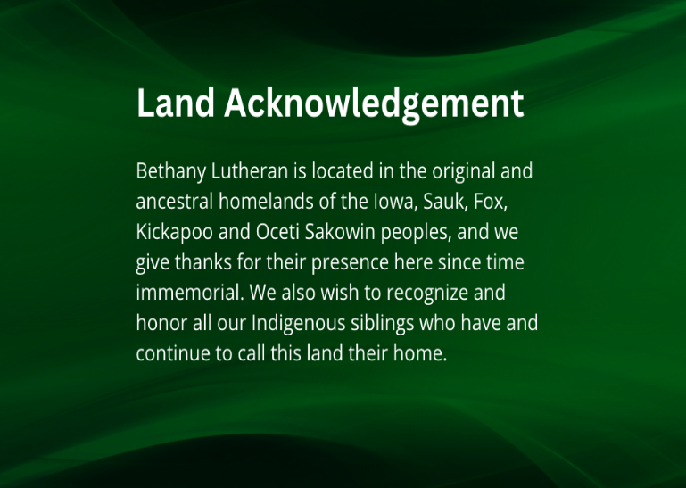

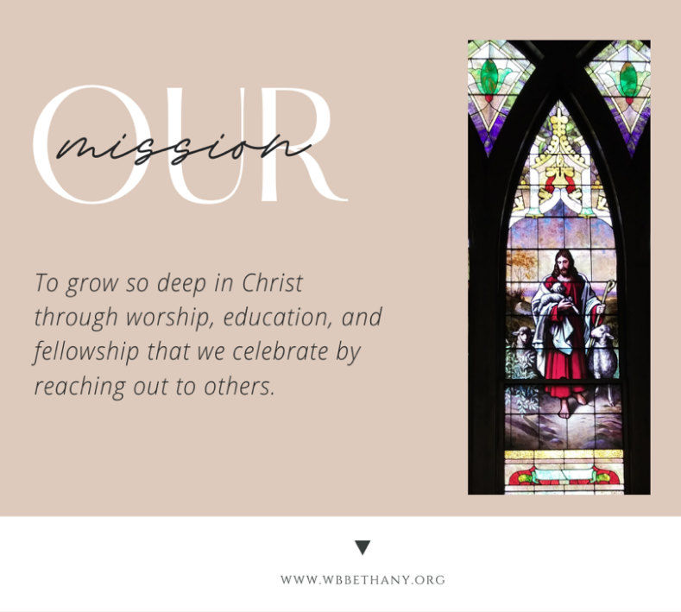

Join us for the Community meal tonight.
5:00-6:00PM in the Great Hall!
Everyone is welcome.

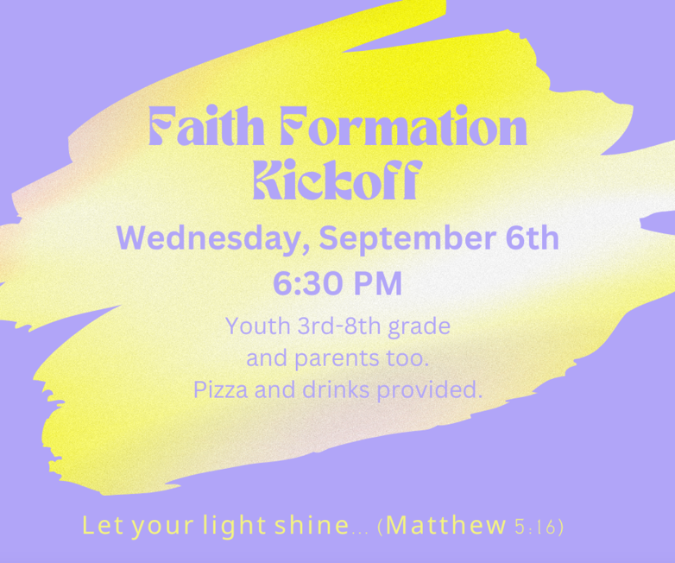

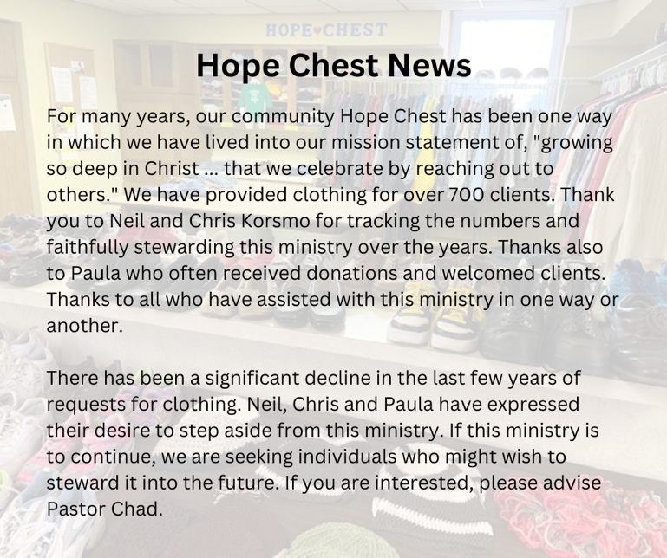

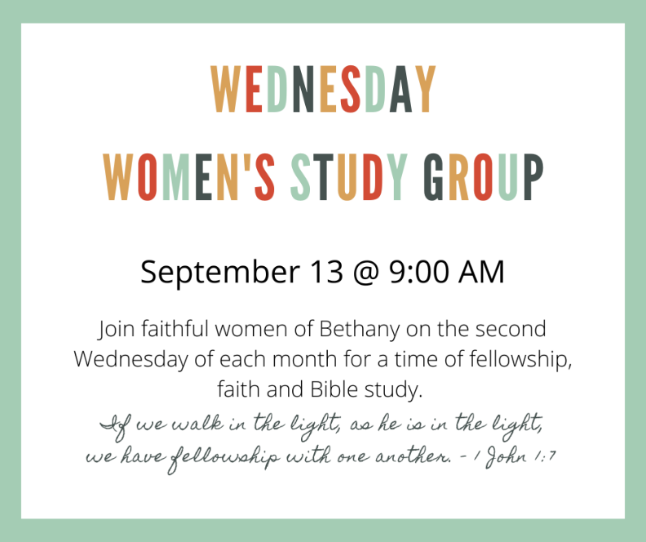
Liturgy from sundaysandseasons.com. Copyright © 2020 Augsburg Fortress. All rights reserved. Used by permission of Augsburg Fortress under license # SB135727.
Halle, Halle, Hallelujah (ELW 172); Arr. © 1995 Augsburg Fortress. Used by permission under OneLicense.net A-726405 streaming license.
Go, My Children, with My Blessing (ELW 543) Text © 1983 Concordia Publishing House Outside USA: Arr. from The English Hymnal © Oxford University Press 1906. All rights reserved. Used by permission under OneLicense.net A-726405 streaming license.
Lord, Listen to Your Children Praying (ELW 752); Text and Music © 1973 Hope Publishing Company. All rights reserved. Used by permission under OneLicense.net A-726405 streaming license.
Scripture from New Revised Standard Version Bible, Copyright © 1989, Division of Christian Education of the National Council of the Churches of Christ in the United States of America. Used by permission. All rights reserved.

