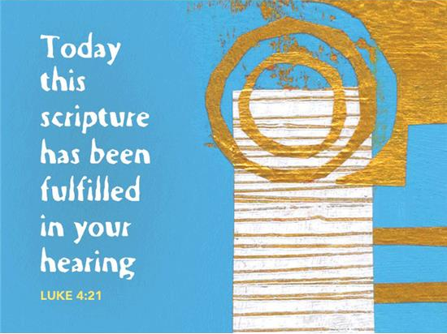

January 30th, 2022
Fourth Sunday after Epiphany
Bethany Lutheran Church (ELCA)

PRELUDE AND LIGHTING OF CANDLES
RINGING OF BELL
WELCOME
GATHERING
The Holy Spirit calls us together as the people of God.

The people of God stand.
CONFESSION AND FORGIVENESS
In the name of the Father,
and of the ☩ Son,
and of the Holy Spirit.
Amen.
God of all mercy and consolation, come to the help of your people, turning us from our sin to live for you alone. Give us the power of your Holy Spirit that we may confess our sin, receive your forgiveness, and grow into the fullness of Jesus Christ, our Savior and Lord.
Amen.
Let us confess our sin in the presence of God and of one another.
Silence is kept for reflection.
Most merciful God,
we confess that we are captive to sin and cannot free ourselves. We have sinned against you in thought, word, and deed, by what we have done and by what we have left undone. We have not loved you with our whole heart; we have not loved our neighbors as ourselves. For the sake of your Son, Jesus Christ, have mercy on us. Forgive us, renew us, and lead us, so that we may delight in your will and walk in your ways, to the glory of your holy name. Amen.

In the mercy of almighty God, Jesus Christ was given to die for us, and for his sake God forgives us all our sins. As a called and ordained minister of the church of Christ, and by his authority, I therefore declare to you the entire forgiveness of all your sins, in the name of the Father, and of the ☩ Son, and of the Holy Spirit.
Amen.
HYMN Rise, Shine, You People! (ELW 665)
GREETING (ELW p.184)
The grace of our Lord Jesus Christ, the love of God,
and the communion of the Holy Spirit be with you all.
And also with you.
KRYIE (ELW p.184)
PRAYER OF THE DAY
Let us pray.
Almighty and ever-living God, increase in us the gifts of faith, hope, and love; and that we may obtain what you promise, make us love what you command, through your Son, Jesus Christ, our Savior and Lord.
Amen.
The people of God are seated.

Word
God speaks to us in scripture reading, preaching, and song.

first READING: Jeremiah 1:4-10
God calls Jeremiah to be a prophet and consecrates him in the womb. Jeremiah’s task is to preach God’s word amid the difficult political realities of his time, before the Babylonian exile. He is to make God known not only to Judah, but also to the nations.
A reading from Jeremiah.

⁴Now the word of the Lord came to me saying, ⁵“Before I formed you in the womb I knew you, and before you were born I consecrated you; I appointed you a prophet to the nations.” ⁶Then I said, “Ah, Lord God! Truly I do not know how to speak, for I am only a boy.” ⁷But the Lord said to me, “Do not say, ‘I am only a boy’; for you shall go to all to whom I send you, and you shall speak whatever I command you. ⁸Do not be afraid of them, for I am with you to deliver you, says the Lord.” ⁹Then the Lord put out his hand and touched my mouth; and the Lord said to me, “Now I have put my words in your mouth. ¹⁰See, today I appoint you over nations and over kingdoms, to pluck up and to pull down, to destroy and to overthrow, to build and to plant.”
The word of the Lord.
Thanks be to God.
PSALM 71:1-6
Psalm 71 is a prayer for help.
¹In you, O Lord, have I taken refuge;
let me never be put to shame.
²In your righteousness, deliver me and set me free;
incline your ear to me and save me.
³Be my strong rock, a castle to keep me safe;
you are my crag and my stronghold.
⁴Deliver me, my God, from the hand of the wicked,
from the clutches of the evildoer and the oppressor.
⁵For you are my hope, O Lord God,
my confidence since I was young.
⁶I have been sustained by you ever since I was born;
from my mother’s womb you have been my strength;
my praise shall be always of you.
second READING: 1 Corinthians 13:1-13
Christians in Corinth prided themselves on their spiritual gifts. Paul reminds them that God gives us many gifts through the Holy Spirit, but the purpose behind all of them is love, the kind of love that God showed us in Jesus Christ.
A reading from 1 Corinthians.
¹If I speak in the tongues of mortals and of angels, but do not have love, I am a noisy gong or a clanging cymbal. ²And if I have prophetic powers, and understand all mysteries and all knowledge, and if I have all faith, so as to remove mountains, but do not have love, I am nothing. ³If I give away all my possessions, and if I hand over my body so that I may boast, but do not have love, I gain nothing.
⁴Love is patient; love is kind; love is not envious or boastful or arrogant ⁵or rude. It does not insist on its own way; it is not irritable or resentful; ⁶it does not rejoice in wrongdoing, but rejoices in the truth. ⁷It bears all things, believes all things, hopes all things, endures all things.
⁸Love never ends. But as for prophecies, they will come to an end; as for tongues, they will cease; as for knowledge, it will come to an end. ⁹For we know only in part, and we prophesy only in part; ¹⁰but when the complete comes, the partial will come to an end. ¹¹When I was a child, I spoke like a child, I thought like a child, I reasoned like a child; when I became an adult, I put an end to childish ways. ¹²For now we see in a mirror, dimly, but then we will see face to face. Now I know only in part; then I will know fully, even as I have been fully known. ¹³And now faith, hope, and love abide, these three; and the greatest of these is love.
The word of the Lord.
Thanks be to God.

The people of God stand.
GOSPEL ACCLAMATION (ELW p.188)
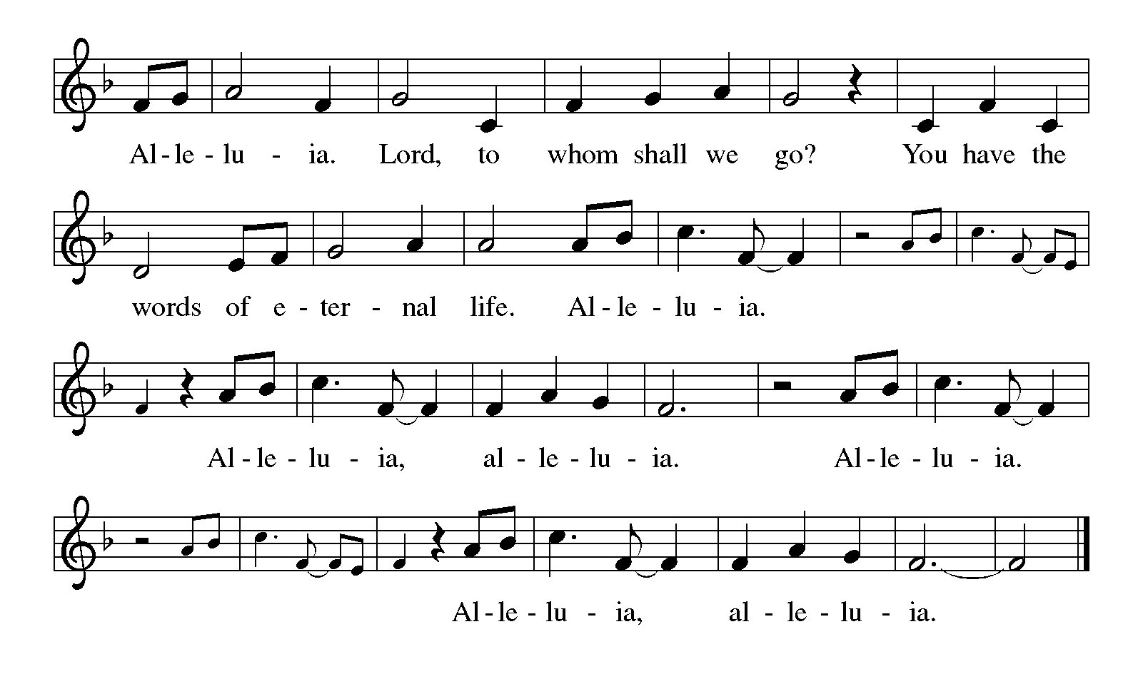
GOSPEL READING: Luke 4:21-30
People in Jesus’ hometown are initially pleased when he says that God will free the oppressed. Their pleasure turns to rage when he reminds them that God’s prophetic mission typically pushes beyond human boundaries so that mercy and healing are extended to those regarded as outsiders.
The holy gospel according to Luke.
Glory to you, O Lord.
²¹Then [Jesus] began to say to [all in the synagogue in Nazareth,] “Today this scripture has been fulfilled in your hearing.” ²²All spoke well of him and were amazed at the gracious words that came from his mouth. They said, “Is not this Joseph’s son?” ²³He said to them, “Doubtless you will quote to me this proverb, ‘Doctor, cure yourself!’ And you will say, ‘Do here also in your hometown the things that we have heard you did at Capernaum.’ ” ²⁴And he said, “Truly I tell you, no prophet is accepted in the prophet’s hometown. ²⁵But the truth is, there were many widows in Israel in the time of Elijah, when the heaven was shut up three years and six months, and there was a severe famine over all the land; ²⁶yet Elijah was sent to none of them except to a widow at Zarephath in Sidon. ²⁷There were also many lepers in Israel in the time of the prophet Elisha, and none of them was cleansed except Naaman the Syrian.” ²⁸When they heard this, all in the synagogue were filled with rage. ²⁹They got up, drove him out of the town, and led him to the brow of the hill on which their town was built, so that they might hurl him off the cliff. ³⁰But he passed through the midst of them and went on his way.
The gospel of the Lord.
Praise to you, O Christ.
The people of God are seated.
SERMON
The people of God stand.
Hymn He Comes to Us as One Unknown (ELW 737) See next page.
APOSTLES’ CREED (ELW p.105)
I believe in God, the Father almighty,
creator of heaven and earth.
I believe in Jesus Christ, God’s only Son, our Lord,
who was conceived by the Holy Spirit,
born of the virgin Mary,
suffered under Pontius Pilate,
was crucified, died, and was buried;
he descended to the dead.
On the third day he rose again;
he ascended into heaven,
he is seated at the right hand of the Father,
and he will come to judge the living and the dead.
I believe in the Holy Spirit,
the holy catholic church,
the communion of saints,
the forgiveness of sins,
the resurrection of the body,
and the life everlasting.
Amen.
Prayers of Intercession
With the whole people of God in Christ Jesus, let us pray for the church, those in need, and all of God’s creation.
Each petition ends with, "Lord, in your mercy.” Those worshipping respond with, "Hear our prayer."
Into your hands, gracious God, we commend all for whom we pray, trusting in your mercy; through Jesus Christ, our Savior.
Amen.
Peace
The peace of Christ be with you always.
And also with you.
The people of God are seated.
WE GIVE THANKS

OFFERING
We are grateful for your gifts and they are needed to continue the work of the church. For those worshipping online, options on ways to give are found on our website (www.wbbethany.org). Thank you! After the offering is gathered, the assembly stands and sings the hymn below as the gifts are brought forward.
OFFERTORY HYMN Change My Heart, O God (ELW 801)
OFFERING PRAYER
Let us pray. Holy God, gracious and merciful, you bring forth food from the earth and nourish your whole creation. Turn our hearts toward those who hunger in any way, that all may know your care; and prepare us now to feast on the bread of life, Jesus Christ, our Savior and Lord. Amen.
MEAL
God feeds us with the presence of Jesus Christ.

GREAT THANKSGIVING (ELW p.190)
The Lord be with you.
And also with you.
Lift up your hearts.
We lift them to the Lord.
Let us give thanks to the Lord our God.
It is right to give our thanks and praise.
It is indeed right, our duty and our joy, that we should at all times and in all places give thanks and praise to you, almighty and merciful God, through our Savior Jesus Christ; who on this day overcame death and the grave, and by his glorious resurrection opened to us the way of everlasting life. And so, with Mary Magdalene and Peter and all the witnesses of the resurrection, with earth and sea and all their creatures, and with angels and archangels, cherubim and seraphim, we praise your name and join their unending hymn:
WORDS OF INSTITUTION
In the night in which he was betrayed,
our Lord Jesus took bread, and gave thanks;
broke it, and gave it to his disciples, saying:
Take and eat; this is my body, given for you.
Do this for the remembrance of me.
Again, after supper, he took the cup, gave thanks,
and gave it for all to drink, saying:
This cup is the new covenant in my blood,
shed for you and for all people for the forgiveness of sin.
Do this for the remembrance of me.
Lord’s Prayer (ELW p.191)
Lord, remember us in your kingdom and teach us to pray.

Our Father, who art in heaven,
hallowed be thy name,
thy kingdom come,
thy will be done,
on earth as it is in heaven.
Give us this day our daily bread;
and forgive us our trespasses,
as we forgive those
who trespass against us;
and lead us not into temptation,
but deliver us from evil.
For thine is the kingdom,
and the power, and the glory,
forever and ever. Amen.

The people of God are seated.
COMMUNION
Communion today will be distributed in a continuous line. The cups in the center of the tray contain white grape juice. All other cups are wine. Gluten-free wafers are available upon request.
All gathered who believe Jesus Christ is their Lord and Savior are invited to come to Holy Communion with repentant hearts believing that Christ forgives our sins and guides our lives. Strengthened, forgiven, and nourished through this meal the Spirit sends us forth in service and to proclaim the good news of Christ’s love. Children and adults who do not take communion may come forward for a blessing.
HYMNS DURING COMMUNION
Lamb of God (ELW p.191)

Christ, Be Our Light (ELW 715)
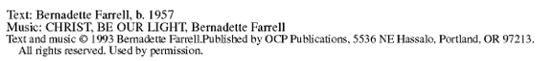
Eat This Bread (ELW 472) Sing twice.
The people of God stand.
BLESSING
PRAYER
Let us pray.
We give you thanks, almighty God, that you have refreshed us through the healing power of this gift of life. In your mercy, strengthen us through this gift, in faith toward you and in fervent love toward one another; for the sake of Jesus Christ our Lord.
Amen.
SENDING
God blesses us and sends us in mission to the world.

BLESSING
The Lord bless you and keep you.
The Lord’s face shine on you with grace and mercy.
The Lord look upon you with favor and ☩ give you peace.
Amen.
HYMN Go, My Children, with My Blessing (ELW 543) See next page.
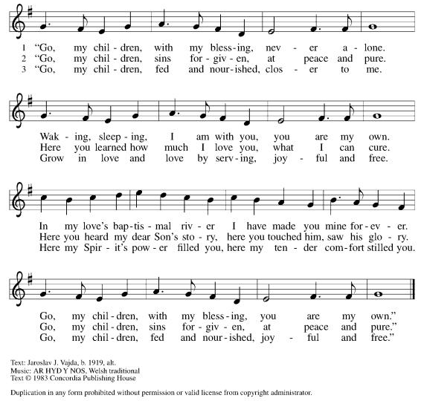
SENDING
Go in peace. Share the good news.
Thanks be to God.
POSTLUDE
OUR WORSHIP ASSISTANTS
Ministers of: | Today | February 6
Music | Beth Kaufman | Jill Barnhart
Proclamation (Lector) | Alan Beyer | Cheryl Boerjan
Christ’s Light (Acolytes)
Minister of Technology | Alex P. | Paula C.
Worship (Altar Care) | Patsy Ernst & Paula Casper | Del & Sue Hughes
Thank you for worshipping with us this morning! We invite you to join us again next Sunday at 9:30 AM in person or live on Facebook. Blessings to you as you shine forth the light of Christ in the world this week! Thanks, and praise to God for everything you do in the name of Jesus Christ!

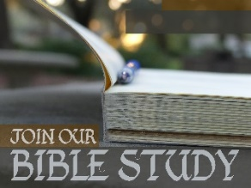
Join us every Monday at noon for a 30-minute discussion about the upcoming Sunday gospel reading. We gather via Zoom Meeting so join at home or work while on your lunch break. If interested, contact Pastor Chad at pastor@wbbethany.org and the Zoom invitation will be forwarded to you. Next Sunday’s gospel is Luke 5:1-11.

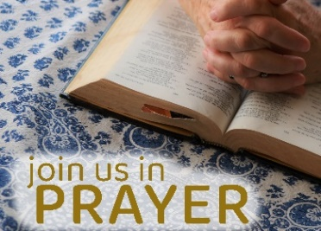
Paula and Pastor Chad gather most Tuesday mornings at 9:00 AM for a short time of prayer. We invite you to join us. If you have a specific prayer request, please post it to our prayer wall on our website (www.wbbethany.org). We would love to pray for you.

Liturgy from sundaysandseasons.com. Copyright © 2020 Augsburg Fortress. All rights reserved. Used by permission of Augsburg Fortress under license # SB135727.
Rise, Shine You People (ELW 665); Text and music © 1974 Augsburg Publishing House admin. Augsburg Fortress All rights reserved. Used by permission under OneLicense.net A-726405 streaming license.
He Comes to Us as One Unknown (ELW 737); Text © 1984 Hope Publishing Company. All rights reserved. Used by permission under OneLicense.net A-726405 streaming license.
Change My Heart, O God (ELW 801); Text and Music © Mercy/Vineyard Publishing, admin. Music Services.
Used by permission under OneLicense.net A-726405 streaming license.
Christ be Our Light (ELW 715); Text and music © 1993 Bernadette Farrell Published by OCP Publications. All rights reserved. Used by permission under OneLicense.net A-726405 streaming license.
Eat This Bread (ELW 472); Text and music © 1984 Les Presses de Taize, GIA Publications Inc, agent. All rights reserved. Used by permission under OneLicense.net A-726405 streaming license.
Go My Children With My Blessing (ELW 543); Text © 1983 Concordia Publishing House. Outside USA: Arr. from The English Hymnal © Oxford University Press 1906.All rights reserved. Used by permission under OneLicense.net A-726405 streaming license.
New Revised Standard Version Bible, Copyright © 1989, Division of Christian Education of the National Council of the Churches of Christ in the United States of America. Used by permission. All rights reserved.

You are loved!

